Use hashmap:to remove loop

Just break the bond between current and prev is current present.

2nd logic:

Now send low to head node

Here low=1 and high=6,here check if low->next==high->next if not move each by 1.

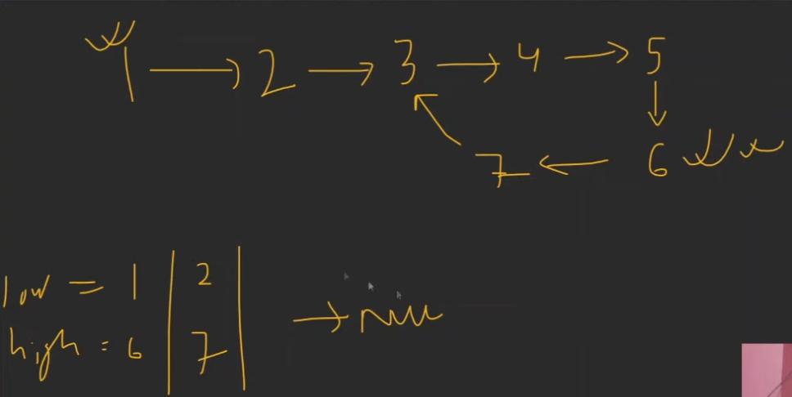

Here 2 next and 7 next are equal. just change 7 next to null.but here 1 exception.

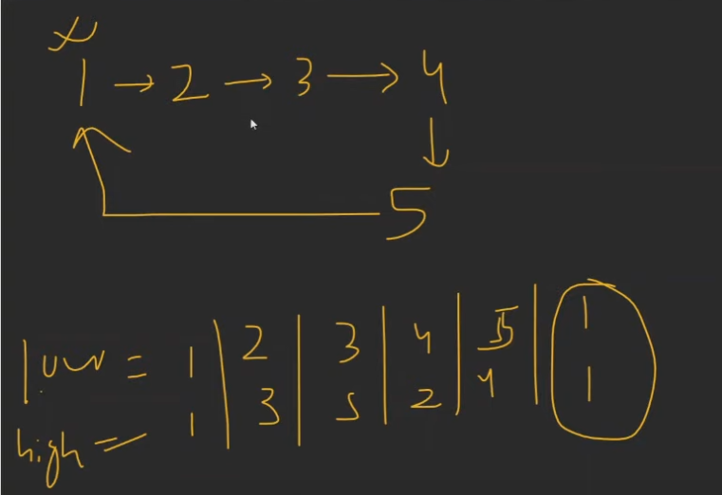

Here if we do low next == head== next it will give wrong answer.here jus check if low and high point to head it tells us loop is at head.her just do high->next!=low for high next.then high->next null do it.

